Chapter 18, Solution 41.

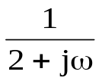
2
2
+
V
−
0.5s
1/s

+
−

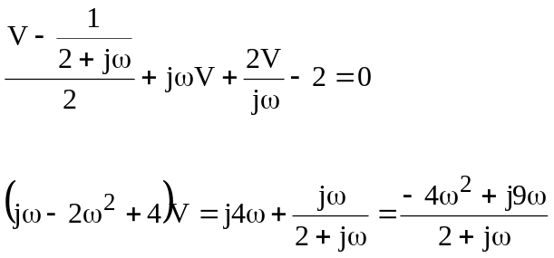

V(ω) = 